  
ESCUELA SUPERIOR   
PÓLITECNICA DEL LITORAL  
  
**WORKSHOP OF   
CODE INSPECTION**  
  
**AUTORES:**

* AGUILAR MORA OSWALDO
* BERMUDEZ MOREIRA KAREN
* BERNAL MOREIRA GUILLERMO
* ORTIZ HOLGUIN EDUARDO
* WONG PAVON HUGO

**SUBJECT:** ING. SOFTWARE II  
**TUTOR:** DR. MERA CARLOS  
**DEADLINE:** 2020/06/26

1. **Abstract**

This document contains the technical report corresponding to the first group workshop called **"WORKSHOP OF CODE INSPECTIOn"** of **GROUP#4** belonging to the **SOFTWARE II ENGINEERING** course of **2020-PAO I**.

The report contains a description of the workshop, the code, the JAVA implementation and the reports.

1. **Description**

PMD is a source code analyzer. It finds common programming flaws like unused variables, empty catch blocks, unnecessary object creation, and so forth. Like other tools, PMD can verify that coding conventions and standards are followed. PMD is more focused on preventive defect detection. It comes with a vast set of rules and is highly configurable. PMD can also configure -in a simple way - particular rules to use in a specific project .

PMD integrates well with IDEs such as Eclipse and NetBeans, and it also fits well into the build

process thanks to its smooth integration with Ant and Maven.

1. **Source Code**
   1. **Repository**

**Github** was used as a collaboration tool for the development of the workshop, the link is:

* <https://github.com/kbermude/Whorskop_CodeInspection>
  1. **Development Considerations**

For the development of the activity and its implementation, the following points were considered:

* **Eclipse** was used as Java IDE.

1. **Activity Screenshots**
   1. **Part 1: Install Maven for Eclipse.**

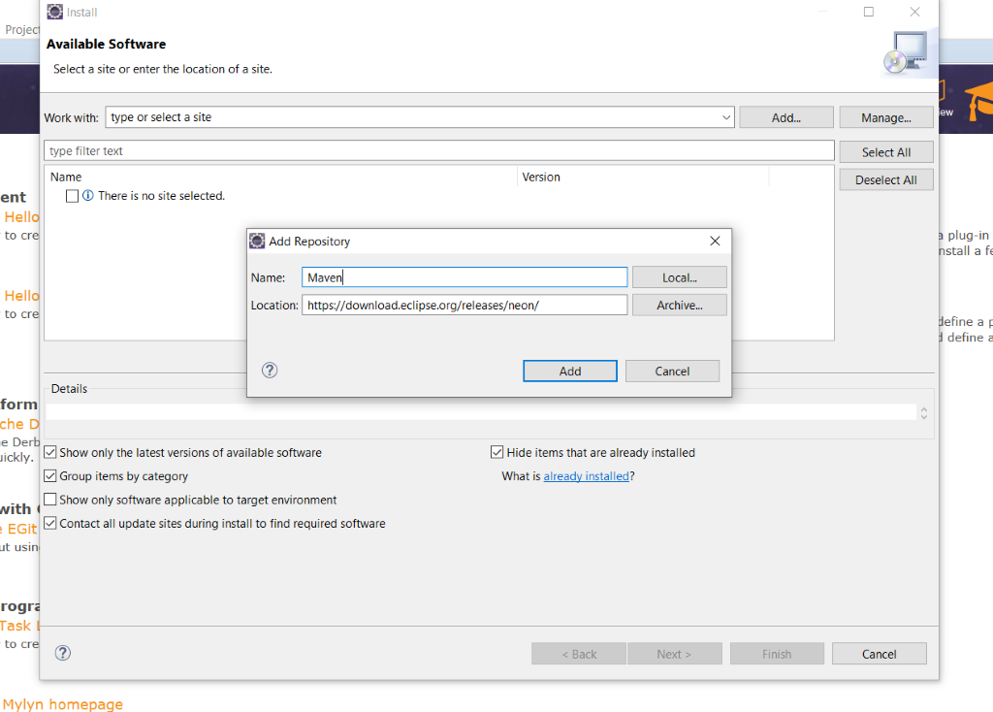

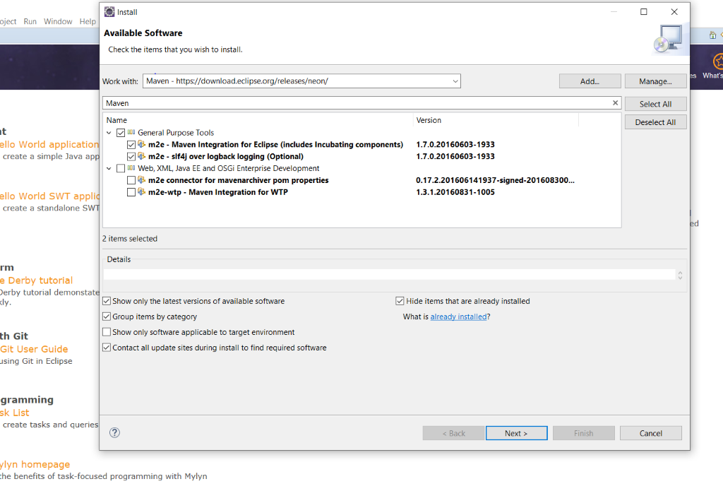

* 1. **Part 2: Install the Eclipse PDM plug-in**

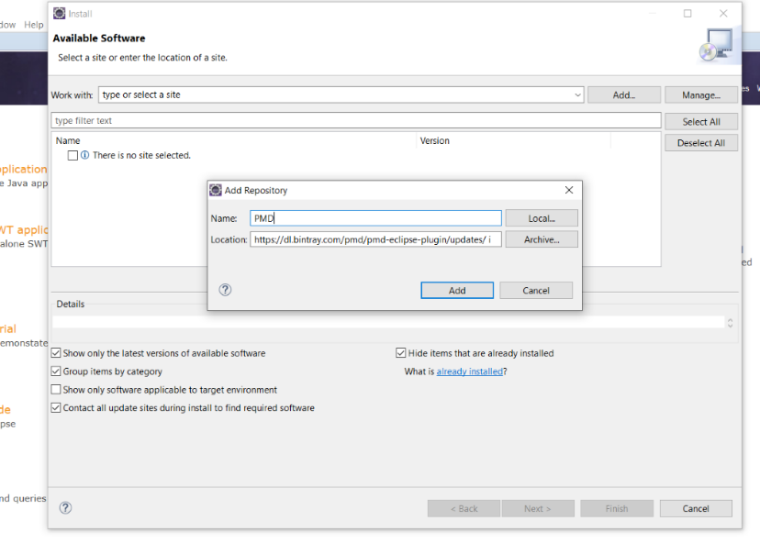

* 1. **Part 3: Download and configure the project**

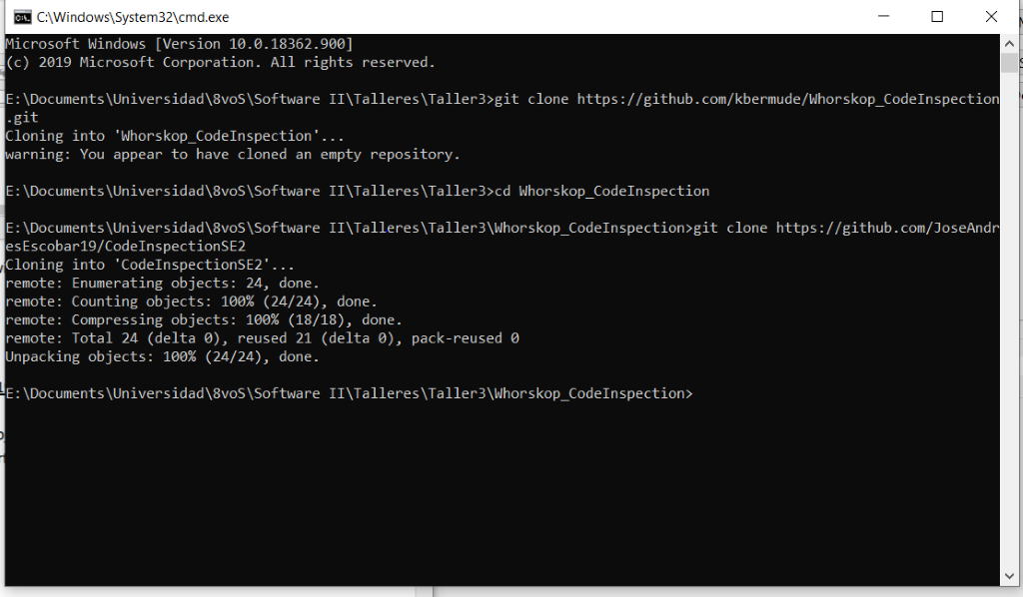

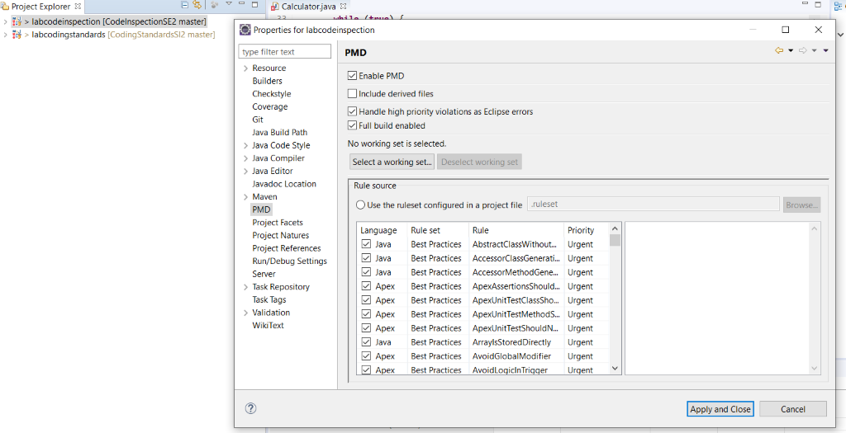

* 1. **Part 4: Using PMD**

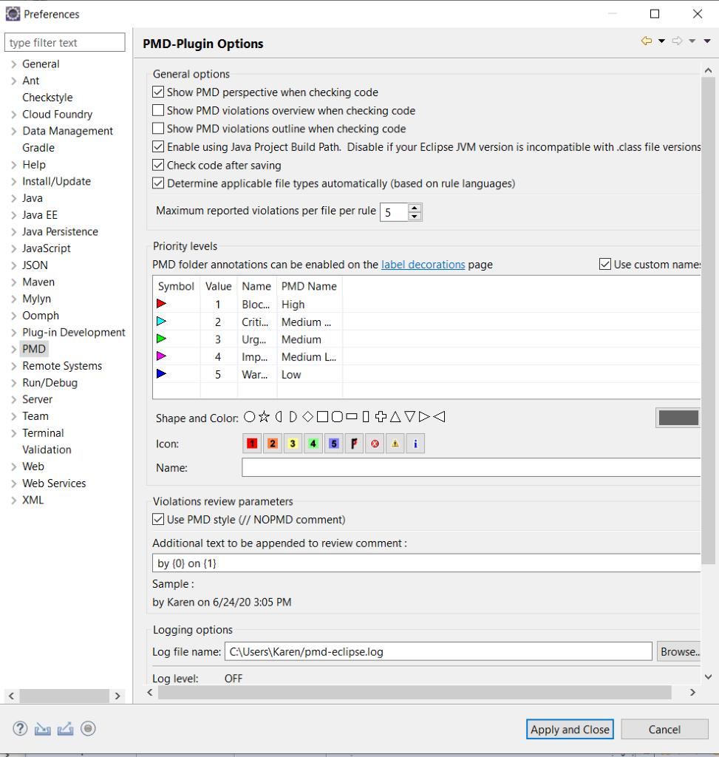

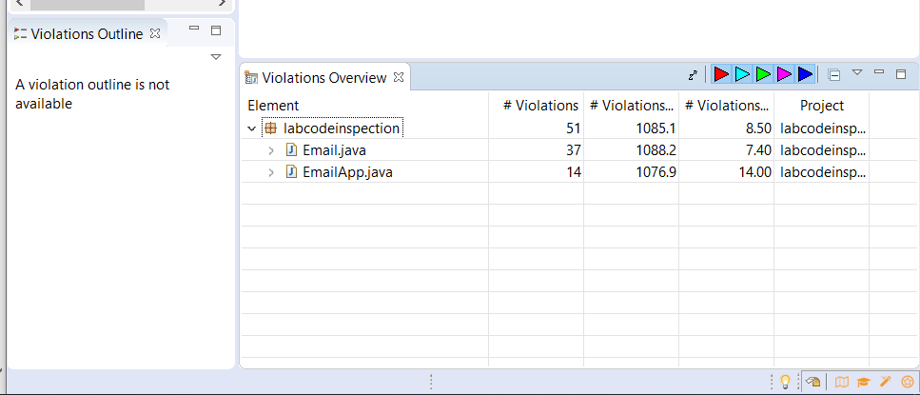

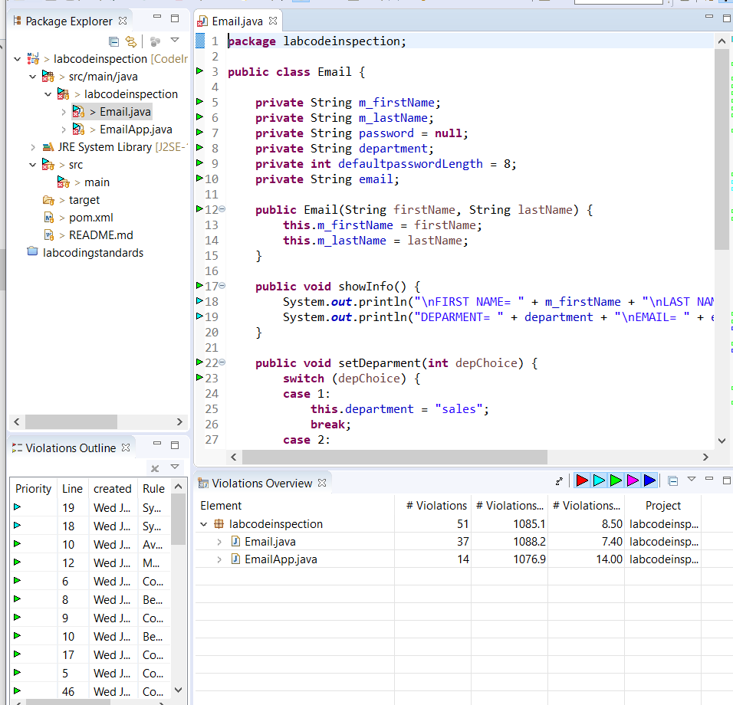

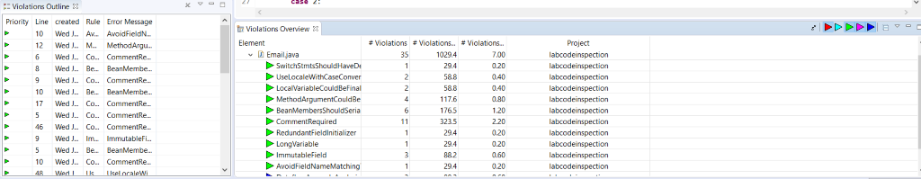

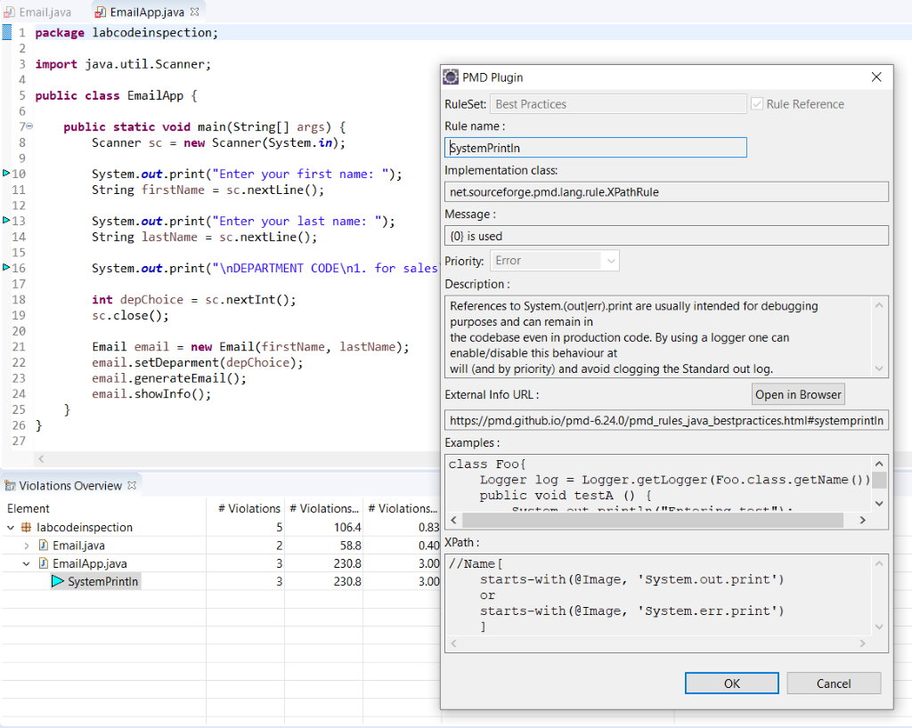

* 1. **Part 5: Creating PMD rulesets**

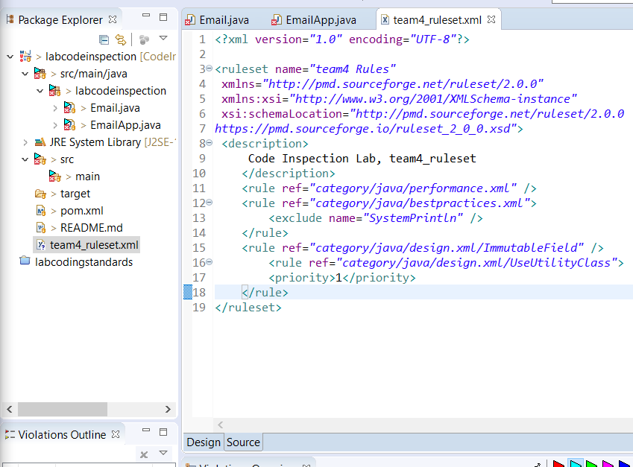

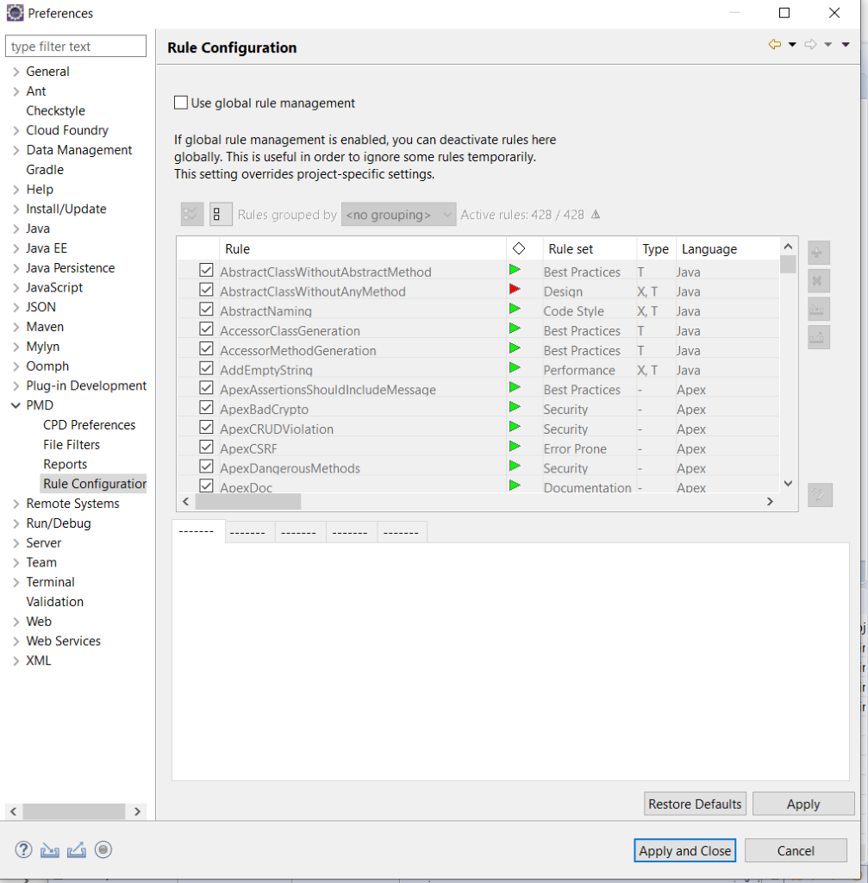

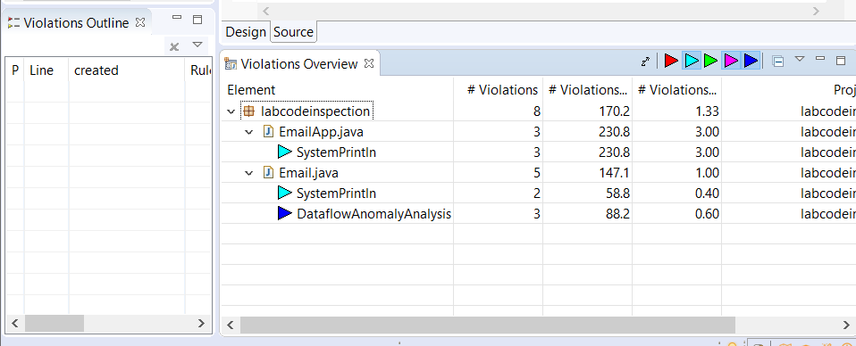

* 1. **Part 6: Generating a PMD report**

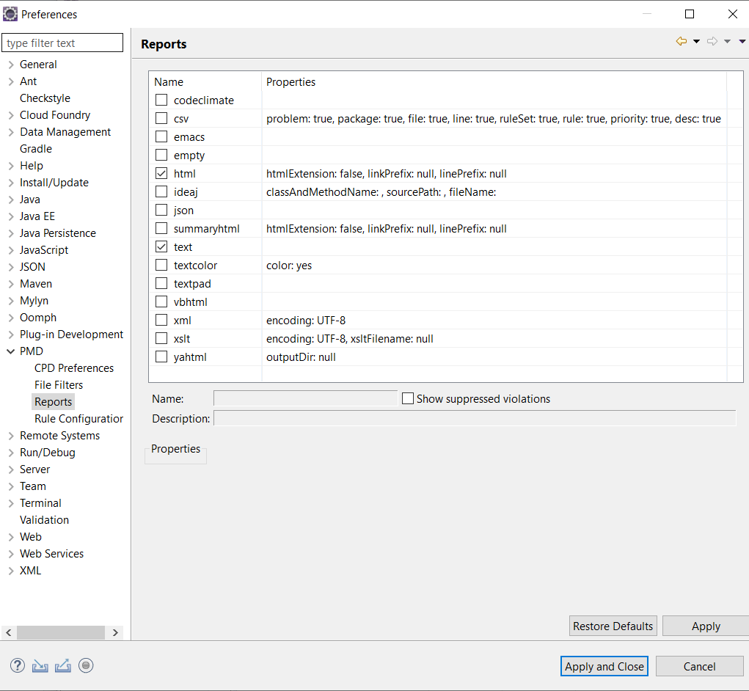

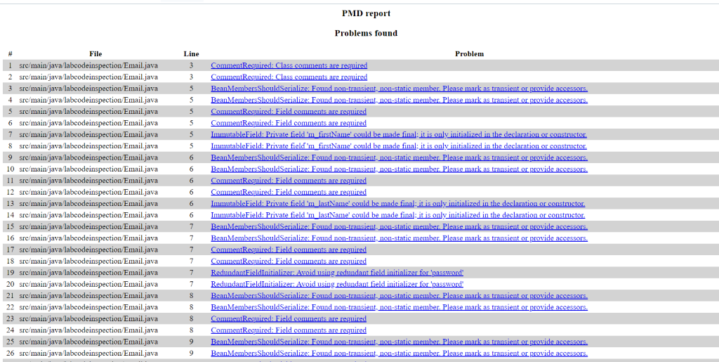

* 1. **Part 7: Suppressing PMD Rules**

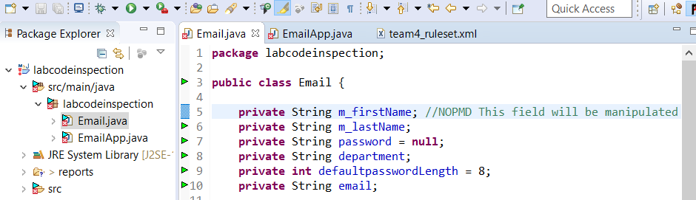

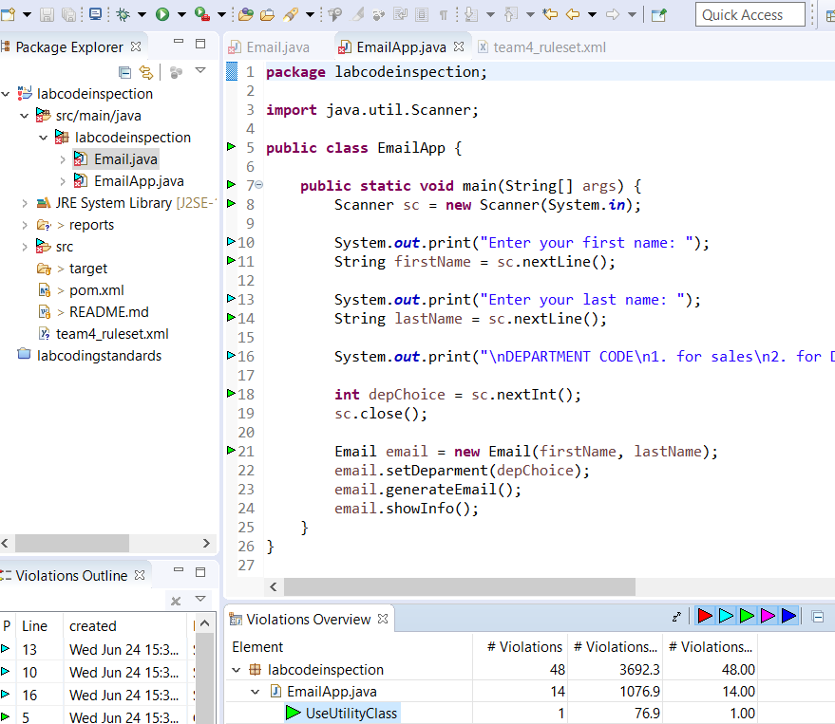

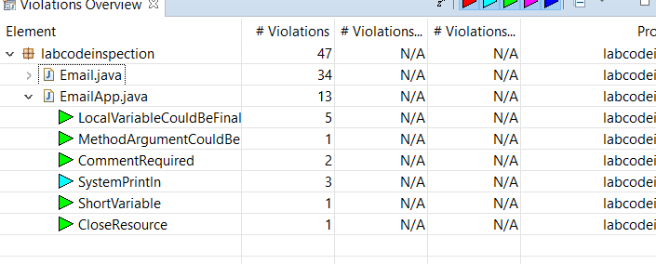

* 1. **Part 8: Detecting Cut-and-Paste with CPD**

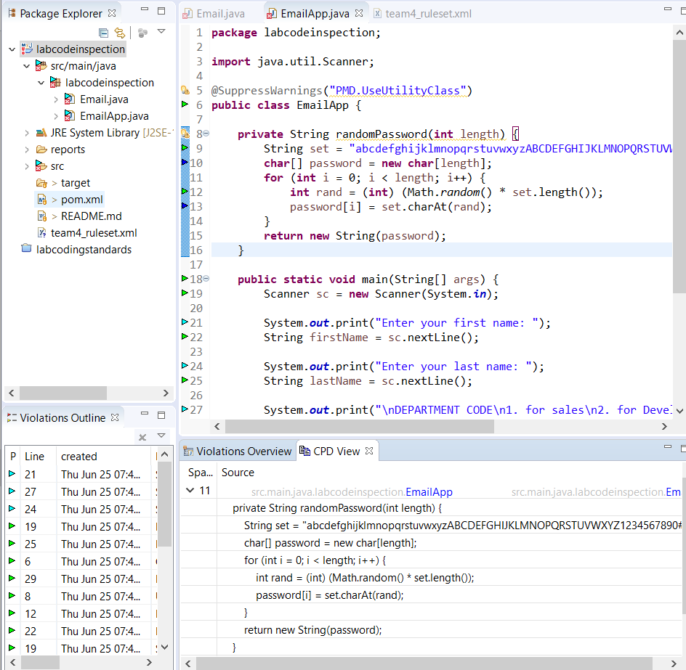

* 1. **Part 9: PMD and Maven**

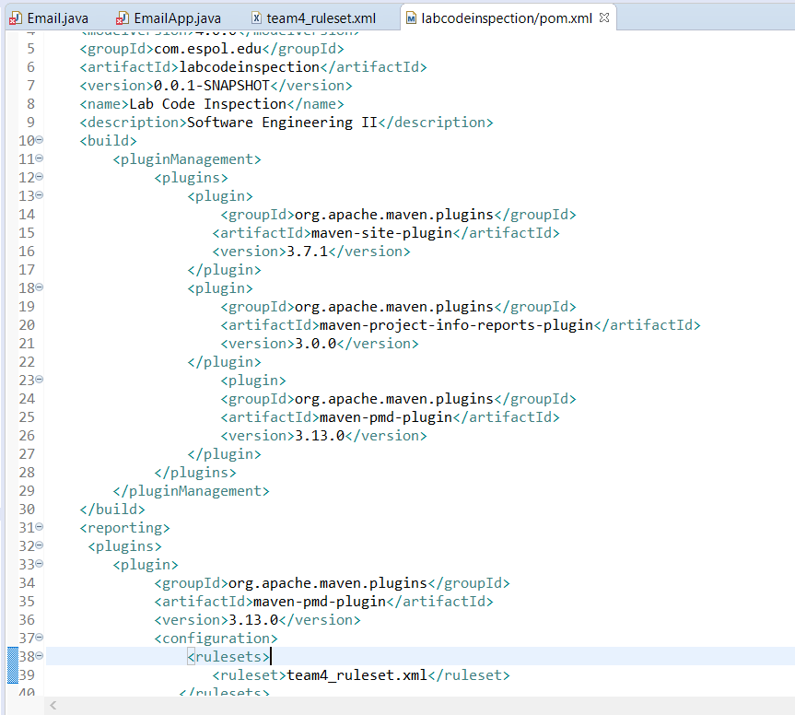

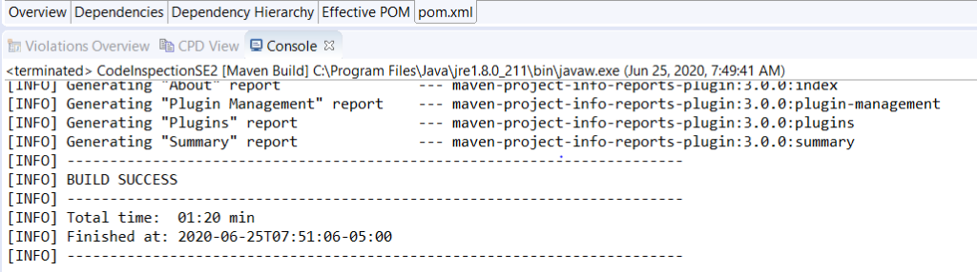

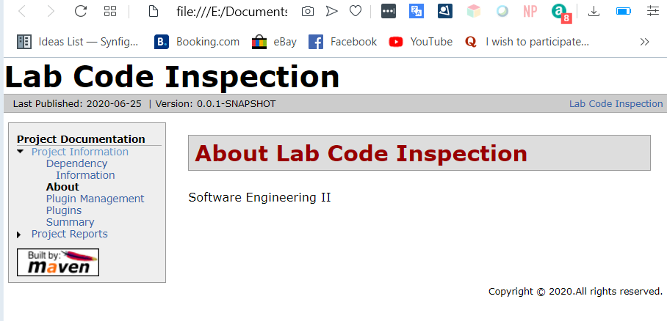

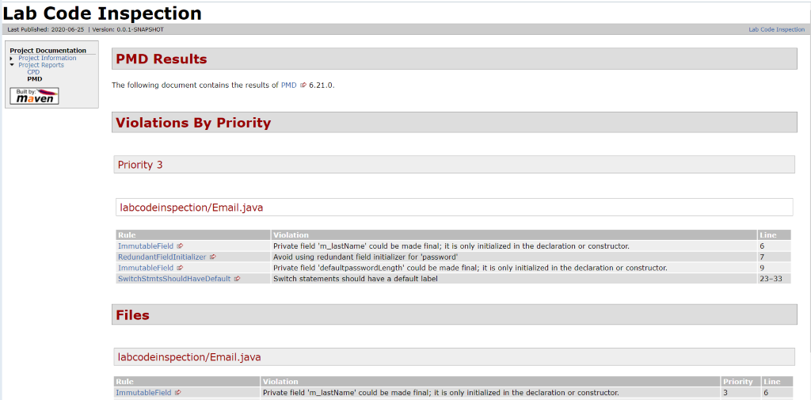

1. **Develpment**

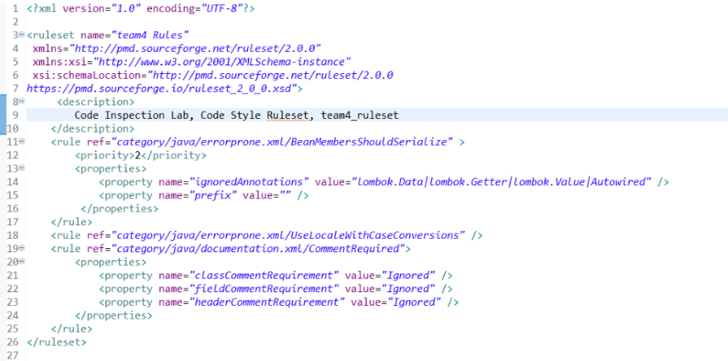

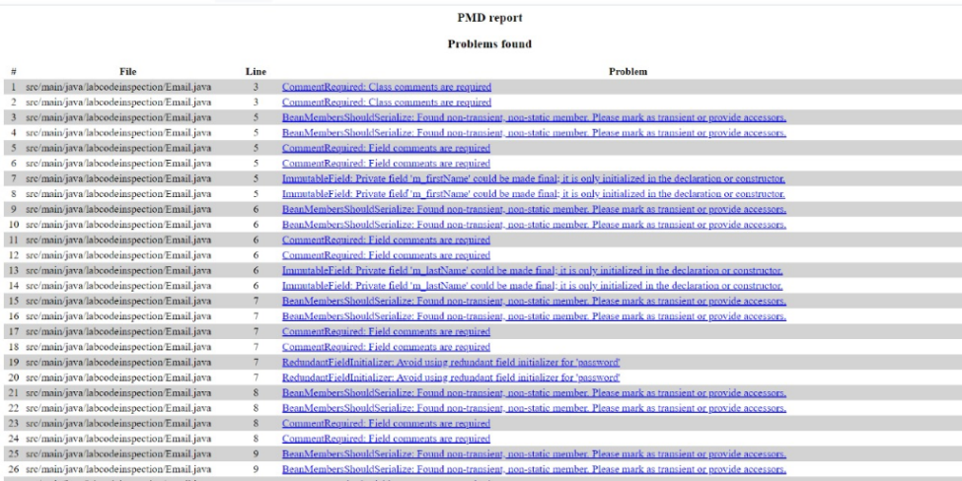

1. **Conclusions**

* This plug-in is a usefull tool to the code inspection.
* The report has a clear format.
* Is easy to implent if you have a guide.